Company Network with VLANs and Inter-VLAN Routing

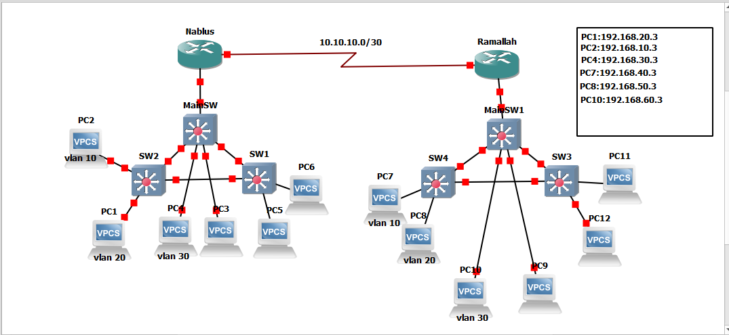

1. Introduction

In this project, a company network is designed and implemented using the GNS3 platform. The goal is to organize the network by dividing it into multiple logical segments using VLANs and enabling communication between them using Inter-VLAN Routing.
This design improves network performance, enhances security, and reflects real-world enterprise network structures.

2. Objectives

The main objectives of this project are:
- To segment the network into multiple VLANs representing different departments
- To reduce broadcast traffic
- To enhance security between departments
- To enable communication between VLANs using routing
- To implement the Router-on-a-Stick technique

3. Network Design

The network is divided into two main sections:

Left Side (Nablus):
- Router (R2)
- Multiple switches (SW1, SW2, MAINSW)
- PCs representing end users
Right Side (Ramallah):
- Router (R1)
- Additional switches
- PCs

4. VLAN Configuration
Three VLANs are created to represent different company departments
Nablus Side
VLAN ID | Network
10 | 192.168.10.0/24
20 | 192.168.20.0/24
30 | 192.168.30.0/24
Each VLAN acts as a separate logical network.
Ramallah Side
VLAN ID | Network
10 | 192.168.40.0/24
20 | 192.168.50.0/24
30 | 192.168.60.0/24

5. Switch Configuration

The following configurations are applied:
- VLANs are created on all switches
- Access ports are assigned to specific VLANs
- Switches are interconnected using trunk ports
Trunk links are used to carry multiple VLANs over a single connection.

6. Inter-VLAN Routing

Inter-VLAN communication is achieved using:
Router-on-a-Stick
This involves:
- Connecting the router to the main switch using a trunk link
- Creating subinterfaces on the router for each VLAN
- Assigning an IP address (default gateway) to each VLAN
This allows devices in different VLANs to communicate.

7. Router Configuration
Routers are configured to:
- Create subinterfaces for each VLAN
- Assign IP addresses to each subnet
- Enable routing between VLANs
Additionally, both routers (Ramallah and Nablus) are connected using a WAN link.

8. Routing Between Networks

Static routing is used to enable communication between:
- Nablus (left side)
- Ramallah (right side)
This allows full connectivity across the entire topology.

9. PC Configuration

Each PC is configured with:
- IP address
- Subnet mask
- Default gateway (based on VLAN)

10. Testing and Verification

The network is tested using the ping command.
Results:
- Devices within the same VLAN communicate successfully
- Devices in different VLANs communicate via the router
- Communication between both networks (Ramallah and Nablus) is successful

11. Challenges Faced

Some issues encountered during implementation include:
- Native VLAN mismatch
- Trunk encapsulation set to auto
- Incorrect default gateway configuration
- Missing trunk links between switches
These issues were resolved by verifying configurations and ensuring consistency across devices.

12. Conclusion

This project successfully demonstrates how to design and implement a segmented network using VLANs and Inter-VLAN Routing.
Key achievements include:

- Logical network segmentation
- Improved performance and reduced broadcast traffic
- Secure communication between departments
- Practical implementation of trunking and routing concepts

This design reflects real-world enterprise networking practices.

13. Future Improvements

The project can be enhanced by adding:

- DHCP server
- Access Control Lists (ACLs)
- Layer 3 switches
- Internet access using NAT

SWITCH CONFIGURATION

enable
configure terminal
vlan 10
name HR
vlan 20
name SALES
vlan 30
name MANAGEMENT
interface range fa0/1 - 3
switchport mode access
switchport access vlan 10
interface range fa0/4 - 6
switchport mode access
switchport access vlan 20
interface range fa0/7 - 9
switchport mode access
switchport access vlan 30

end
write memory

TRUNK CONFIGURATION

enable
configure terminal
vlan 99
name NATIVE
interface fa0/24
switchport trunk encapsulation dot1q
switchport mode trunk
switchport trunk native vlan 99
no shutdown

end
write memory

ROUTER R2 (Nablus)

enable
configure terminal
interface fa0/0
no shutdown
interface fa0/0.10
encapsulation dot1Q 10
ip address 192.168.10.1 255.255.255.0
interface fa0/0.20
encapsulation dot1Q 20
ip address 192.168.20.1 255.255.255.0
interface fa0/0.30
encapsulation dot1Q 30
ip address 192.168.30.1 255.255.255.0

end
write memory

ROUTER R1 (Ramallah)

enable
configure terminal
interface fa0/0
no shutdown
interface fa0/0.10
encapsulation dot1Q 10
ip address 192.168.40.1 255.255.255.0
interface fa0/0.20
encapsulation dot1Q 20
ip address 192.168.50.1 255.255.255.0
interface fa0/0.30
encapsulation dot1Q 30
ip address 192.168.60.1 255.255.255.0

end
write memory

ROUTER LINK (R1 ↔ R2)

R1:
interface s0/0
ip address 10.0.0.1 255.255.255.252
no shutdown

R2:
interface s0/0
ip address 10.0.0.2 255.255.255.252
no shutdown

STATIC ROUTING

R1:
ip route 192.168.10.0 255.255.255.0 10.0.0.2
ip route 192.168.20.0 255.255.255.0 10.0.0.2
ip route 192.168.30.0 255.255.255.0 10.0.0.2

R2:
ip route 192.168.40.0 255.255.255.0 10.0.0.1
ip route 192.168.50.0 255.255.255.0 10.0.0.1
ip route 192.168.60.0 255.255.255.0 10.0.0.1

PC CONFIGURATION

VLAN 10 :
PC2 → IP: 192.168.10.3 /24 VLAN 10 GW: 192.168.10.1
PC5 → IP: 192.168.10.4 /24 VLAN 10 GW: 192.168.10.1
PC7 → IP: 192.168.40.3 /24 VLAN 10 GW: 192.168.40.1
PC12 → IP: 192.168.40.4 /24 VLAN 10 GW: 192.168.40.1

VLAN 20 :
PC1 → IP: 192.168.20.3 /24 VLAN 20 GW: 192.168.20.1
PC3 → IP: 192.168.20.4 /24 VLAN 20 GW: 192.168.20.1
PC8 → IP: 192.168.50.3 /24 VLAN 20 GW: 192.168.50.1
PC9 → IP: 192.168.50.4 /24 VLAN 20 GW: 192.168.50.1

VLAN 30 :
PC4 → IP: 192.168.30.3 /24 VLAN 30 GW: 192.168.30.1
PC6 → IP: 192.168.30.4 /24 VLAN 30 GW: 192.168.30.1
PC10 → IP: 192.168.60.3 /24 VLAN 30 GW: 192.168.60.1
PC11 → IP: 192.168.60.4 /24 VLAN 30 GW: 192.168.60.1

